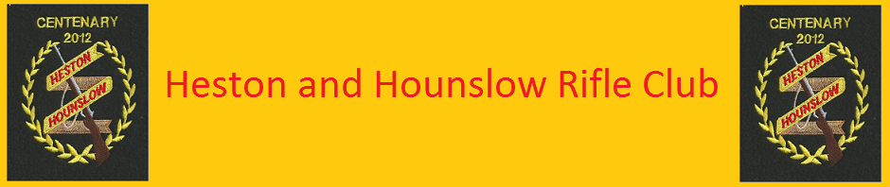

**Welcome**

**to**

**Heston and Hounslow Rifle Club**



**Beginners guide**

**to**

**Small-bore Rifle Target Shooting**

**Part one, Safety and Club Rules**

**Range Safety**

The rules given here are an example of Small-bore target rifle range safety rules. There is an official set for guidance provided by the N.S.R.A. and these may be provided to the shooter by many clubs when they attend the first shoot.

General Rule: Firearms are only ever safe (unloaded) when they are proven to be empty. Unloaded rifles should always have breech flags inserted which provide visible indications that the rifle is safe.

Specific rules:

* Only the shooter plus a single instructor may be on a single firing point lane at any one time. Anyone who is watching must stand to the rear of the firing point.
* Rifles must only be carried or moved when the bolt, or lever, is open and a breech flag is visible in the chamber
* Never point a rifle at another person, not even when it is unloaded.
* Only ever close the bolt when the rifle is pointing down the range towards the target.
* Rifles are only ever loaded when they are on the firing point and aiming down the range towards the targets or stop butts. A rifle cannot be removed from the firing point when loaded. Permission to load must also have been given by the range officer.
* On rare occasions rounds may not fire when the trigger has been squeezed, this is known as a misfire. If a misfire occurs the rifle should be unloaded carefully, and the misfired round given to the range conducting officer to dispose of safely
* Never remove a loaded rifle from the firing point and always unload the rifle before getting up from the firing point. Even if the shooter is only moving a short distance away from the rifle it should be unloaded and a breech flag inserted.
* Never go in front of a person who is shooting. No one may move towards the targets unless the range officer has said the range is clear and people may move forwards. If there is a problem with a target during the shoot the range officer should be notified.
* If the range officer says STOP then everyone must stop firing, unload, and insert a breech flag. Further instructions will be given by the Range officer.
* **The rules are given here for reference and it is strongly recommend that they are read and any questions should be raised to the instructor at whichever club the reader attends.**
* Each club follows a set of standard safety rules, but, there may have additional bespoke rules within their own clubs. Always listen to the range office and follow any specific instruction given.

**Personal Safety**

* Every time the rifle is fired a loud noise is made. This ‘crack’ can permanently damage the hearing of anyone in close proximity, and no one is closer to the noise than the person firing the rifle.
* Clubs providing opportunities for people to learn to shoot must ensure hearing protection of sufficient quality is made available. Hearing protection takes the form of ear defenders or ear plugs. It is important that the quality of the equipment is sufficient – if the equipment provided appears to be damaged, does not fit or is in any way unsuitable it must be raised to the instructor prior to the start of firing.
* For shooters under the age of 18 the rifle club can be held accountable for damage to hearing caused by shooting if suitable protection is not provided. Therefore clubs must provide hearing protection of the required standard and ensure it is worn by the shooter at the correct times.   
  Adults must be provided with the correct equipment but are liable for their own decision to wear it or not.
* As with many sports the shooter is advised to be aware that if they have any concerns about eye safety then eye protection can be worn without detrimental effect to the ability to shoot.
* There are rules in addition to the ones listed here. Follow these and shooting will be a safe and enjoyable experience. Fail to follow these rules and a shooter may be removed from the range and not allowed to shoot again at that club or any other in the same region.

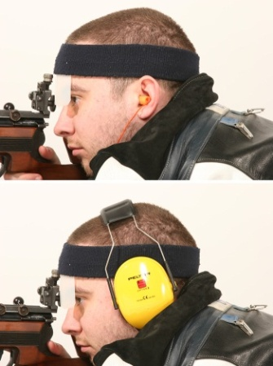

**Wash your hands after shooting**

A shooter should be aware that handling firearms and ammunition will leave a residue of oils, lead and other chemicals on their hands which should be washed properly at the end of the session or before eating. 

**In addition..**

**As mentioned in Safety, Heston and Hounslow Rifle Club have their own additional rules which all members are obliged to adhere too.**

**The detail board is there to advise who is on the next detail, if your name isn’t on the board it will be assumed you are not shooting or not ready to shoot. Please make sure this is maintained at all times.**

**Make sure your cards are ready to be taken down as soon as the previous detail is finished.**

**All rifles will be returned to the clubhouse (flags in) before the cards are changed.**

**One person from the incoming detail will change the cards for all and take down all cards that are ready for the next detail.**

**25 yard details are 10 minutes and long range 20 minutes.**

**The exterior door must be locked and the key returned to the range officer before the next detail can start.**

**Failure to adhere to club rules or a breach in range safety will attract disciplinary action, repeat offenders will be asked to leave the club by the committee.**

**The Committee work in the best interest of the club and its members at all times. While not every decision is always agreed with by every member, please respect and adhere to the requests made. It will always be made for in the interest of the majority. Thank you.**

**Etiquette**

* + **Be ready to shoot on your detail without hold ups.**
  + **Late arrival and delay causes distraction**
  + **No mobile phones on firing point**
  + **No talking when others are shooting**
  + **Do Not access or leave the firing point while others are shooting ( except for short range while long range are shooting)**
  + **Do not fiddle with equipment, collect empties or leave the firing point until all are finished**
  + **At the end of your detail, pick up empties and leave the firing point as you would expect to find it.**



**Welcome**

**To**

**Heston and Hounslow Rifle Club**

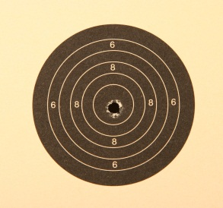

**Beginners guide**

**to**

**Small-bore Rifle Target Shooting**

**Part Two, Getting Started**

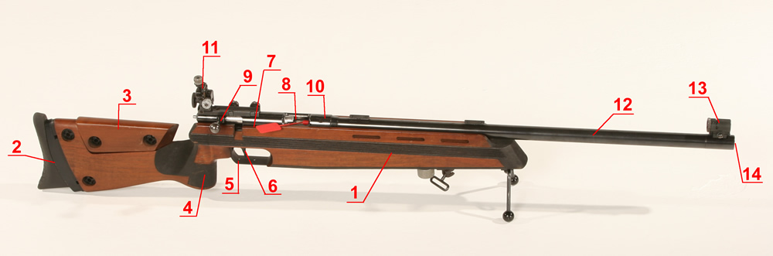

**Definitions**

1. **Stock:** The body of the rifle. Historically this is made from a single, solid piece of wood (walnut or ash), but modern rifles can have laminated wood or Aluminium stocks and can be made up of multiple sections. This is the part of the rifle that the shooter will have contact with whilst holding the rifle.
2. **Butt:** This part of the stock sits against the shooter’s shoulder when the rifle is held.
3. **Cheek piece:** The cheek of the shooter will be placed on/against this whilst firing and it provides a platform to help align the eye with the sights.
4. **Pistol grip:** The firing hand of the shooter lightly grips the pistol grip and provides the correct position for the trigger finger.
5. **Trigger guard:** This is a protective guard that is fitted to the stock and prevents the trigger from being knocked or damaged accidentally when the rifle is being moved.
6. **Trigger:** The trigger is the device that translates the motion of the finger into the firing of the rifle and is fixed to the underside of the action.
7. **Action:** a metal housing that is fixed into the stock that connects the trigger, bolt and barrel together.
8. **Breech:** This is an opening in the top of the action where the ammunition is loaded into the rifle and is the entry point to the chamber.
9. **Bolt:** The bolt is used to push the round fully into the chamber, provides a seal around the end of the chamber during firing and it also holds the firing pin. When the round had been fired the bolt is used to extract the empty ammunition case from the chamber and eject it from the rifle.
10. **Chamber:** The ammunition will be sealed into the chamber prior to firing. The chamber also contains the force of the explosion used to propel the bullet through the barrel.
11. **Rear sight:** This is used in conjunction with the foresight to aim the rifle at the target and is positioned on top of the action about 3 inches in front of the eye that is used for aiming**.**
12. **Barrel:** The metal tube that connects into the action and sits on top of the stock. The inside of the tube has a spiral twist cut into it which makes the bullet spin as it flies through the air.
13. **Foresight:** The foresight is fitted to the muzzle end of the barrel and is lined up with the rear sight and the target to accurately aim the rifle.
14. **Muzzle:** The end of the barrel where the bullet will emerge when the rifle is fired.

**THE FIRST TIME WITH A RIFLE**

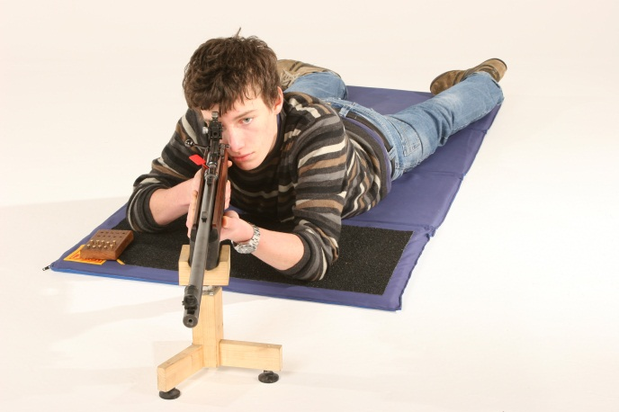

The first time anyone lies down to shoot with a small-bore target rifle should be both a fun and safe experience. There is plenty of theory that can be given to a person before they start shooting, theory about ammunition grades, rifle types, techniques for breathing and trigger release amongst others. At this early stage most people are eager to find out if shooting is a sport that they will enjoy or not and the best way to do that is to get down behind a rifle and shoot at a target or two.

This hopefully provides an introduction to the target rifle, the type of kit that is likely to be used during the first sessions, safety and a short guide on how to take the first shots with a rifle as well as what to expect from the whole experience – keeping in mind it is about having fun as well as being safe and accurate.

In addition to the mandatory safety briefing and orientation of the rifle some basic theory should be provided to a new shooter before any shots are fired. The theory cover the basics of loading, aiming, use of the trigger and what to expect when the shot is fired. The theory is important to enable the shooter to get the most out of their first shots but a balance should be found between proving useful information and allowing the shooter to get hands on practical experience.

**Core Skills**

Small-bore target rifle shooting is a sport in which the key skill is being able to reproduce the exact same set of actions each and every time a shot is fired. Numerous different things can affect where the shot hits the target, and each has a different magnitude of effect on the shot. The best thing to do is to first learn the core skills that have the greatest effect on the shot, and then once those have been mastered the remaining things can be covered one by one.

For small-bore rifle shooting there are three core skills: Breathing [rhythm], Aiming [Sight picture] Trigger Control and follow through and the prone position.

**Breathing**

**How breathing affects the body and the shot**

When a person breathes their chest expands and if they are lying flat on their stomach each breath taken raises the body up off the ground a little bit. If the person lying down is holding a rifle the breathing motion will be transferred to the rifle – and the task of aiming precisely is made a lot more difficult with a moving rifle. This is why, for a few seconds, whilst aiming and firing a shot the shooter must hold their breath. To minimise the movement in the rifle when breathing the shooter should raise the right knee (for a right handed shooter) as this has the effect of raising the diaphragm allowing for expansion and contraction of the lungs without the body lifting significantly up and down.

**Important**

Do not hold a breath, breath out and hold, but not for long, after aprox 5-7 seconds the oxygen levels in the blood start to reduce which will have an immediate effect on the shooters vision. If a breath is held in the lungs for too long then physiological affects begin to occur as the level of Oxygen in the lungs becomes insufficient to meet the needs of the body. These affects will impact the ability of the shooter to accurately focus on the rifle sights and the target.

**Aiming**

Aiming with a small-bore target rifle involves lining up three separate points; a pair of sights (a rear sight and a fore sight) with one at each end of the rifle, and the target as the third aiming point. The image the shooter sees when looking through the sights is called the 'sight picture'. If all 3 elements of the sight picture are aligned accurately the shooter will be able to hit the target when the shot is fired – simple.

There are different types of sight used on target rifles, each does the same thing (aids the shooter in aiming the rifle) but in a different way. The most common sights for Small-bore rifles are the circular sights but shooters may also come across blade and notch sights.

When aiming, the rear sight will never be well defined or clear because it is positioned too close to the eye and the eye cannot focus on objects closer than 15cm.

The foresight is about 100cm away from the eye and the target is 25 yards away (depending on the length of the range) and both of these can easily be independently focused on. What the eye cannot do is focus on both the foresight and the target at the same time.

The shooter should focus on the foresight instead of the target. In this case the target should appear as a slightly blurred spot and the eye will automatically try to make the shooter line up the target and the foresight. If the eye focuses on the target the foresight becomes blurry and it is much harder to align the target and the sights, thus making it harder to shoot accurately.

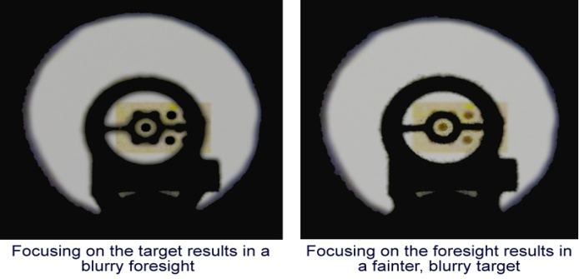

**Sight picture**

The term ‘sight picture’ refers to what is seen when the shooter looks through the rear sight. The picture is made up from the different elements of the rifles’ sights and the target, with the sight picture being either good or bad.

The correct sight picture is gained by focusing on the foresight, ensuring the foresight is visible in the centre of the rear sight and lining up the slightly blurry target in the centre of the foresight before taking the shot. This is the very basic method for aiming and should result in the shot hitting the black area of the target. However this by itself will not be enough to shoot a consistent group of shots which all hit the target very close together

To achieve a tight group the three elements of the sight picture must be perfectly aligned. The target and foresight are relatively easy to align when the rifle is supported, this is because the rifle and therefore the sights do not move very much and can be seen quite clearly. Aligning the foresight in the centre of the rear sight is a little harder. The rear sight of a rifle should not be more than 10cm away from the eye (5-7cm is recommended) and the human eye cannot clearly focus on something that is closer than 15cm (8-10cm for healthy young eyes). In addition, the hole in the centre of the rear sight is roughly 1mm in diameter and the eye must focus through this hole to be able to see the foresight. The result of this focus is that the rear sight appears as a blurry black circular hole and does not have a crisp clean edge.

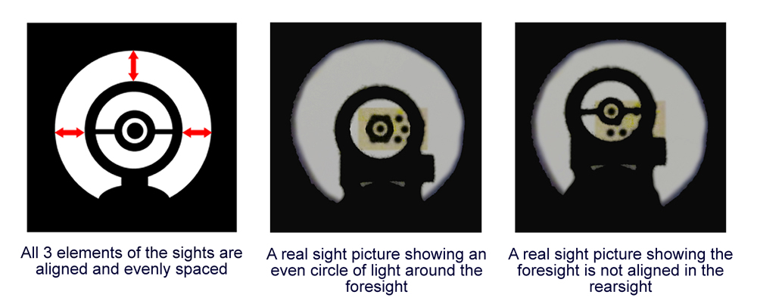

**Trigger Control**

The trigger should be squeezed when the shooter is happy that the sight picture is correct and the breath is being held with lungs half full. Squeezing the trigger may only take a couple of seconds but it can have a large effect on where the shot hits the target and is one of the four core skills for rifle shooting.

**Finger position on the trigger**

Although it may seem like a very small thing, the position of the index finger on the trigger can make the rifle move and cause a shot to miss as the trigger is squeezed. A finger has a different sensitivity in each location, some parts of it are better at feeling ‘touch’ than others. The pad of the finger is quite sensitive whereas the area around the first joint is less sensitive.

Although it is preferable to have the most sensitive part of the finger in contact with the trigger it will also depend on how stiff the trigger is along with the position of the hand and finger in relation to the rifle and trigger. A very sensitive trigger can be easily squeezed with the tip of a finger, but a stiff trigger will need a greater force to move it and this will be easier if the trigger is closer to the first joint.

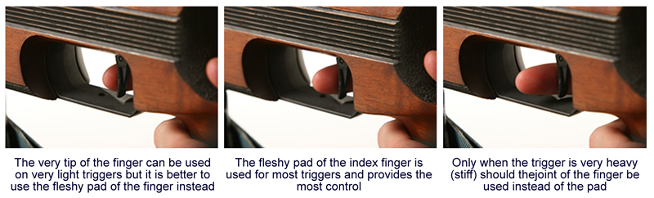

**Personal notes**

**Rifle :-**

**Settings :-**

**General :-**